# **BRANDING**

Branding creates a unique and memorable identity for a product, company, or organization. It is also the crucial key that contributes to the values and visions to raise awareness and make people recognize and perceive brand image and identity in the proper way.

## **Brand Concept**



| The AXONS logo concept embodies the idea of continuous progress without complaint. It signifies a commitment  to innovation to improve everyone's quality of life. The graphics and materials symbolize the seamless integration of "life" and "technology." The directional lines in the design represent growth, quality, and the pursuit of ***DRIVING FUTURE FOR LIVES*** |
| --- |

### **Corporate Logo Colors**

We play a crucial role in maintaining design consistency. Straying from the designated colors can convey the wrong messages. Designers should ensure that the logo precisely matches the specified colors whenever it appears in any media. The primary logo comprises three colors: green, blue, and black (AXONS). It should be consistently used across various media to establish a memorable and unified brand image.

|  |  |  |
| --- | --- | --- |
| **Green**  #22AB68  rgb(34, 171, 104) | **Driven Blue**  #074E9F  rgb(7, 78, 159) | **Black** #3B3A3C  rgb(59, 58, 60) |

### **Single Colors & Reverse Version**

AXONS's logo usage has certain restrictions. Sometimes, these restrictions arise when the logo's background is the same, making the emblem less prominent. In other cases, it's practical considerations, like budget constraints for printing within the company or creating souvenirs with colored backgrounds. In such situations, opting for the logo to ensure better clarity and visibility is advisable.

**Single Version**



**Reverse Version**

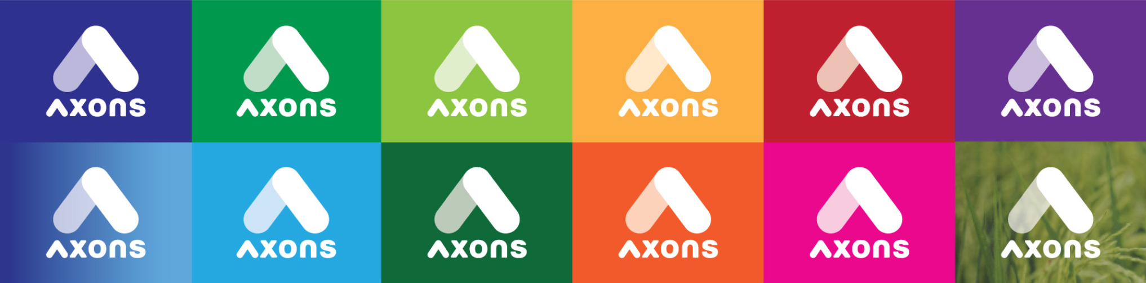

### 

### **Clear Space**

Clear space is considered one of the vital elements of a logo proposition. To emphasize the logo's significance,

designers should place it in an area that can be quickly and prominently seen and attract people's attention without distractions like text or graphics nearby. To maintain this clear space, designers can apply some suggestions to their designs, as below:

**Preferred Clear Space:** The logo should extend beyond the dotted line, with the left and right sides of the dotted line equivalent to two vertical "A's" (as in AXONS). Ensure that the top and bottom spaces are equal to one horizontal "A" away from the dotted lines.

### 

**Minimum Clear Space:** The logo should have open space extending beyond the dotted line, both above and below it, using the vertical height of one letter "A" from the AXONS logo as a guide. This space should be maintained on all sides of the logo, equivalent to the size of one letter "A."

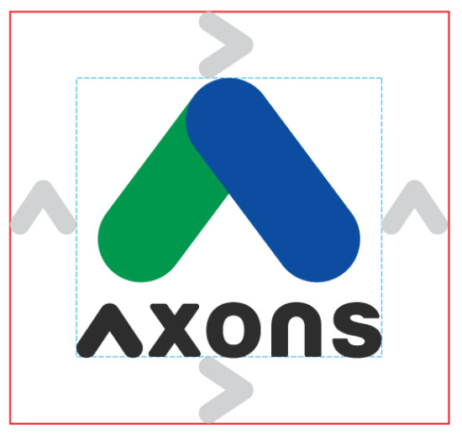

### 

### **Logo Minimum Size**

There should not be a logo that is less than **10 mm** or **106 pixels.**

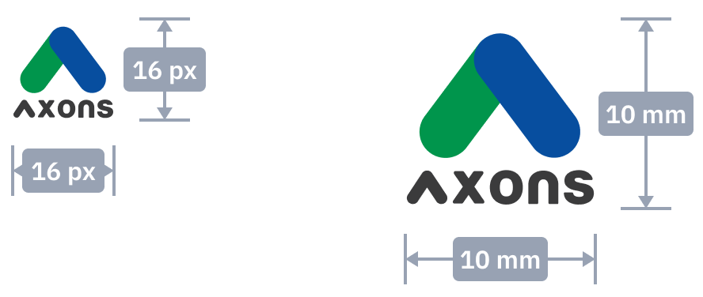

### **Logo Usages**

#### ***Background logo usages:***

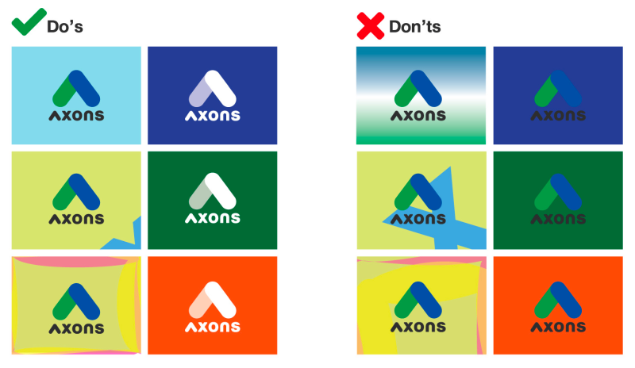

#### ***Incorrect Logo Usages:***

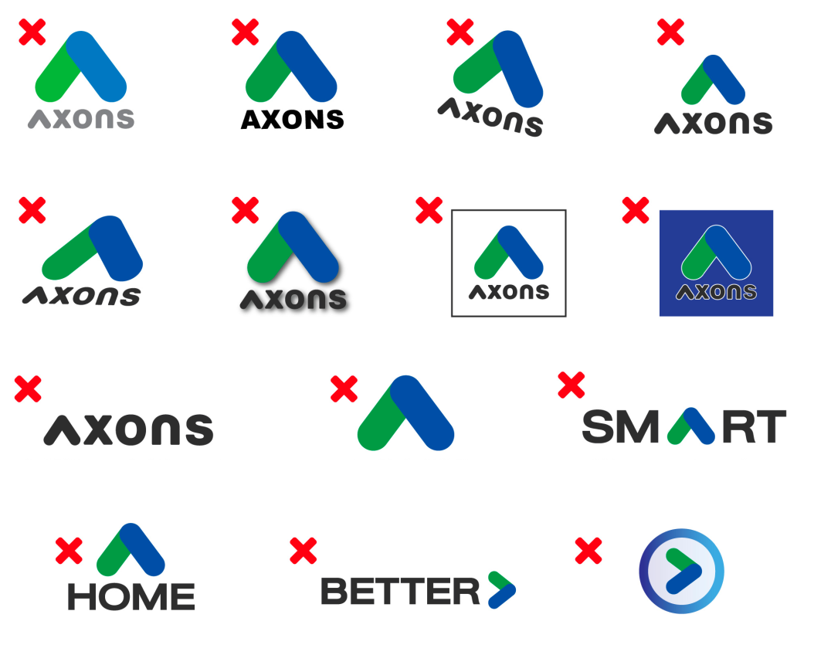

# 

## Brand Identity

### **Color palettes**

The use of color plays an essential role in establishing brand identity and brand awareness. For AXONS, the color palettes are based on two primary colors, which are also the logo's colors. These primary colors are employed in various designs. Additionally, there's a secondary group of colors (Secondary color) that complements the primary ones. This secondary palette adds visual appeal while preserving the core identity of the AXONS brand.

#### ***Primary Colors:***

|  |  |
| --- | --- |
| **Green**  #22AB68  rgb(34, 171, 104) | **Driven Blue**  #074E9F  rgb(7, 78, 159) |

### **Programming typeface**

The programming typeface is a specific font or typography style that is commonly used by programmers and software developers when writing code. Programming typefaces are designed to enhance readability and reduce eye strain when working with code for extended periods.

#### ***IBM Plex Sans Thai & IBM Plex Sans Thai Looped***

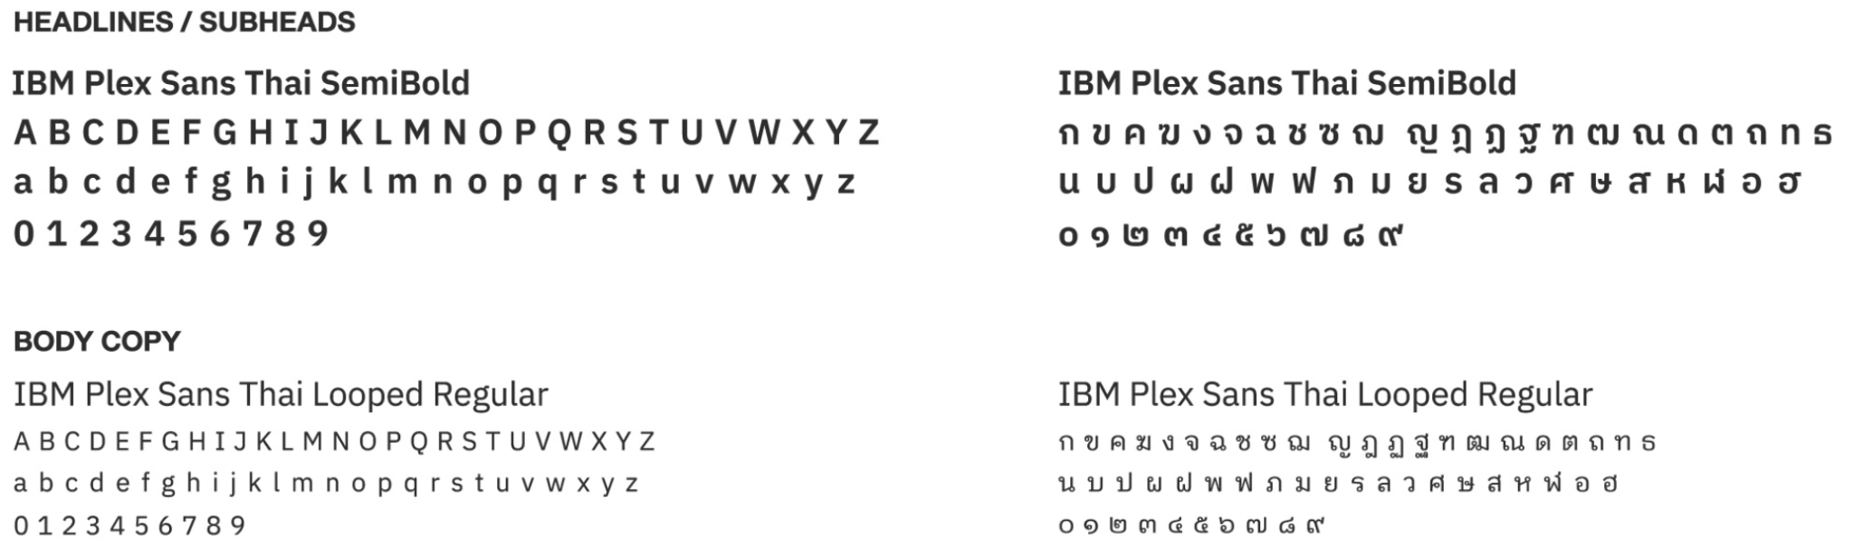

### **Element**

Graphic elements are visual components used in design and art, including shapes, lines, typography, images, icons, colors, textures, symbols, and more. They are used to convey messages, enhance aesthetics, and serve various purposes in compositions.

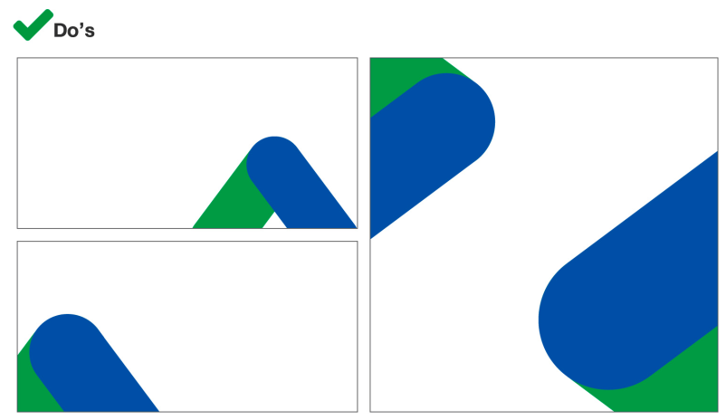

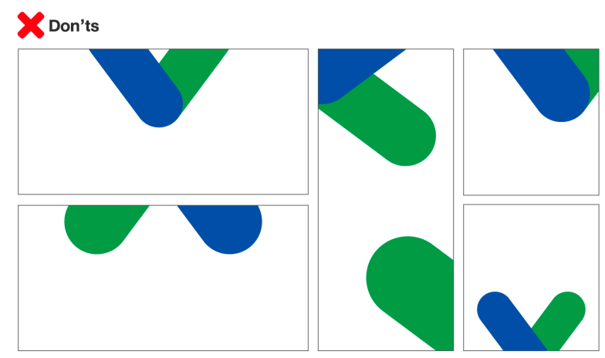

### **Tagline**

A brand tagline is a concise phrase or slogan associated with a brand, used to convey its essence, value, or identity. For AXONS, the tagline "Driving Future For Lives" represents brand values that are passionate about building values for all stakeholders, including country, community, and corporate. The tagline reflects AXONS' missions that aim to develop innovative and functional solutions to improve the quality of lives of people, businesses, and society.

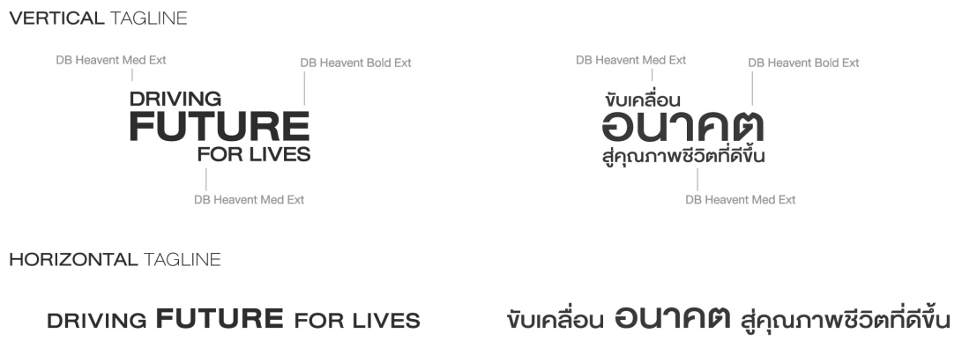

# **DESIGN PHILOSOPHY**

## **Product's Logo**

A product logo is a small visual symbol representing a mobile or desktop application that helps users quickly access and recognize the application. Following platform guidelines for consistency and compatibility is vital for branding and user convenience.

### Principle

For maintaining the consistency of brand style, there are essential criteria for creating icons that designers can apply to their work, as below;

### 

### 

### **Scalability**

We design App Icons to be versatile, considering various screen placements and sizes. Our icons remain detailed, beautiful, and descriptive regardless of where they're used, whether on the screen or in media.

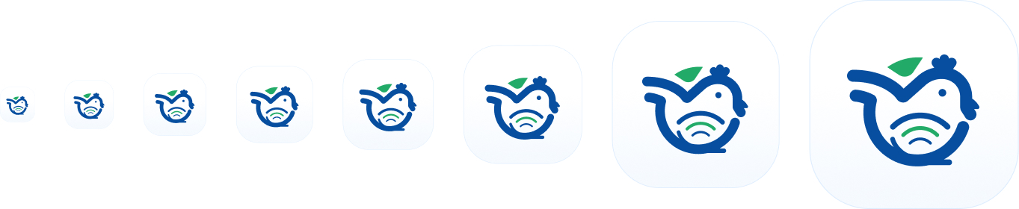

### 

### **Recognizability**

A critical role of a product logo is representing the brand, including brand identity, brand values, and brand personalities. The logo reflects the mood and tone of these things by displaying them through shapes, lines, colors, and other visual elements that comprise them as one logo. When people see it, they can be aware of and recognize the brand's uniqueness.

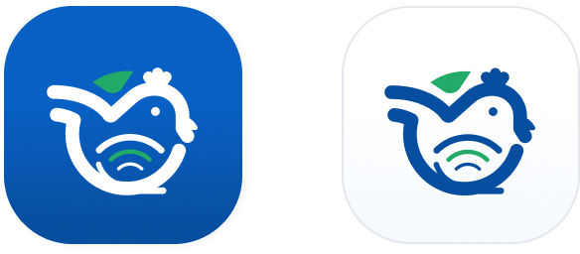

### 

### **Consistency**

Our App Icon design maintains consistency to ensure our brand remains memorable. We focus on the level of detail, color, shape, and font, always following the same direction. This consistency allows people to recognize our brand even as we develop more applications. When they see an App Icon with this design style, including look, color, and detail, they can confidently identify it as an application under the AXONS's brand.

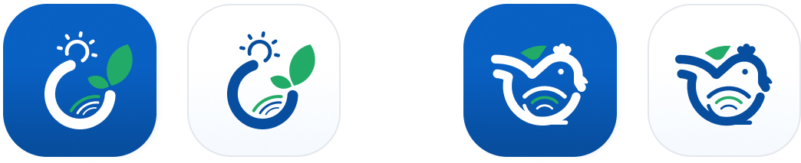

## **Grid**

### **App Icon Grid**

The app icon grid provides icon design guidelines for applications. Designers can ensure design consistency and uniformity across platforms and devices based on the element.

|  | **Pixel Grid 24dp**  The Pixel grid in app design is a visual aid that aligns design elements to the pixel grid, ensuring crisp and clear visuals on screens. |
| --- | --- |
|  | **Live area 20dp**  The live area on the app icon is the central portion where the main content is placed. Designers should place it as the most prominent part of the icon, focusing on the key visual elements. |
|  | **Padding 2dp**  The padding on the app icon is the space or margin surrounding the central content of the icon. It provides a buffer between the main content and the icon's edge, ensuring the content doesn't appear  too crowded or close to the edge. Also, it helps maintain a balanced and visually pleasing appearance. |
|  | **Round corners (Radius)**  This element refers to the curvature and smoothness applied to the corners of the icon's shape. Radius is typically measured in pixels; a specific radius value determines how much the corners are rounded.  It's available in various styles depending on the design and the desired aesthetics, but it's often used to make icons appear more modern and user-friendly. |

## **Anatomy**

### **App Icon Anatomy**

Various visual and design elements constitute an app icon. These elements include the icon's shape, color scheme, graphics, typography, and other visual components contributing to its overall appearance. Understanding its anatomy is crucial for designing and optimizing it to represent the app and be visually appealing to users effectively.

|  |  |  |  |
| --- | --- | --- | --- |
| **Anatomy (Material Design)** | **Keyshapes** | **Orthogonal** | **Mask** |

## **Colors**

Colors design systems use predefined colors to ensure a consistent and effective visual presentation across various platforms and contexts.

#### 

#### Main colors

| **Primary** | | | | |
| --- | --- | --- | --- | --- |
| main/primary/default  #074E9F  rgba(7, 78, 159, 100%) | main/primary/on-default  #F5FAFE  rgba(245, 250, 254, 100%) | main/primary/container  #BDDBFC  rgba(189, 219, 252, 100%) | main/primary/on-container  #0A6EE1  rgba(10, 110, 225, 100%) | main/primary/osurface  #BDDBFC  rgba(189, 219, 252, 100%) |
| **Secondary** | | | | |
| main/secondary/default  #22AB67  rgba(34, 171, 103, 100%) | main/secondary/on-default  #F7FCFA  rgba(247, 252, 250, 100%) | main/secondary/container  #C8EEDB  rgba(200, 238, 219, 100%) | main/secondary/on-container  #43BC80  rgba(67, 188, 128, 100%) | main/secondary/surface  #C8EEDB  rgba(200, 238, 219, 100%) |
| **Descriptive Text** | | | | |
| main/descriptive-text/norma  l  #344054  rgba(52, 64, 84, 100%) | main/descriptive-text/light  #667085  rgba(102, 112, 133, 100%) | main/descriptive-text/lighter  #8A95A8  rgba(138, 149, 168, 100%) | main/descriptive-text/lightest  #E4E7EC  rgba(228, 231, 236, 100%) |  |
| **Outline** | | | | |
| main/outline/primary  #DEEDFE  rgba(222, 237, 254, 100%) | main/outline/secondary  #E3F7ED  rgba(227, 247, 237, 100%) | main/outline/lighter-gray  #E4E7EC  rgba(228, 231, 236, 100%) | main/outline/gray  #A6B0BF  rgba(166, 176, 191, 100%) | main/outline/darker-gray  #667085  rgba(102, 112, 133, 100%) |
| main/outline/focus  #0A6EE1  rgba(10, 110, 225, 100%) |  |  |  |  |
| **Surface** | | | | |
| main/surface/primary  #F5FAFE  rgba(245, 250, 254, 100%) | main/surface/secondary  #F7FCFA  rgba(247, 252, 250, 100%) | main/surface/level03  #FFFFFF  rgba(255, 255, 255, 100%) | main/surface/level02  #FFFFFF  rgba(255, 255, 255, 100%) | main/surface/level01  #FFFFFF  rgba(255, 255, 255, 100%) |
| main/surface/level01  #F2F4F7  rgba(242, 244, 247, 100%) |  |  |  |  |
| **Base** | | | | |
| main/base/white  #FFFFFF  rgba(255, 255, 255, 100%) | main/base/gray  #F6F7F9  rgba(246, 247, 249, 100%) | main/base/light  #8A95A8  rgba(138, 149, 168, 100%) | main/base/lighter  #667085  rgba(102, 112, 133, 100%) | main/base/dark  #344054  rgba(52, 64, 84, 100%) |
| main/base/darker  #101828  rgba(16, 24, 40, 100%) |  |  |  |  |
| **Link-Text** | | | | |
| main/link-text/normal  #0A6EE1  rgba(10, 110, 225, 100%) | main/link-text/neutral  #344054  rgba(52, 64, 84, 100%) |  |  |  |
| **Success** | | | | |
| main/success/default  #07A721  rgba(7, 167, 33, 100%) | main/success/on-default  #F9FBF9  rgba(249, 251, 249, 100%) | main/success/container  #E4F0E5  rgba(228, 240, 229, 100%) | main/success/on-container  #06951E  rgba(6, 149, 30, 100%) | main/success/surface  #E4F0E5  rgba(228, 240, 229, 100%) |
| **Success-spare** | | | | |
| main/success-spare/default  #00B2AA  rgba(0, 178, 170, 100%) | main/success-spare/on-default  #F9FCFB  rgba(249, 252, 251, 100%) | main/success-spare/container  #E4F2F0  rgba(228, 242, 240, 100%) | main/success-spare/on-container  #009F98  rgba(0, 159, 152, 100%) | main/success-spare/surface  #E4F2F0  rgba(228, 242, 240, 100%) |
| **Error** | | | | |
| main/error/default  #D92D20  rgba(217, 45, 32, 100%) | main/error/on-default  #FDF9F9  rgba(253, 249, 249, 100%) | main/error/container  #F8E5E5  rgba(248, 229, 229, 100%) | main/error/on-container  #C2281D  rgba(194, 40, 29, 100%) | main/error/surface  #F8E5E5  rgba(248, 229, 229, 100%) |
| **Error-Spare** | | | | |
| main/error-spare/default  #E5347C  rgba(229, 52, 124, 100%) | main/error-spare/on-default  #FEF9FA  rgba(254, 249, 250, 100%) | main/error-spare/container  #FAE5EB  rgba(250, 229, 235, 100%) | main/error-spare/on-container  #CD2F6F  rgba(205, 47, 111, 100%) | main/error-spare/surface  #FAE5EB  rgba(250, 229, 235, 100%) |
| **Warning** | | | | |
| main/warning/default  #F8BD26  rgba(248, 189, 38, 100%) | main/warning/on-default  #FFFCF9  rgba(255, 252, 249, 100%) | main/warning/container  #FEF3E5  rgba(250, 229, 235, 100%) | main/warning/on-container  #DEA922  rgba(222, 169, 34, 100%) | main/warning/surface  #FEF3E5  rgba(254, 243, 229, 100%) |
| **Warning-Spare** | | | | |
| main/warning-spare/default  #F79009  rgba(247, 144, 9, 100%) | main/warning-spare/on-default  #FFFBF9  rgba(255, 251, 249, 100%) | main/warning-spare/container  #FDEDE4  rgba(253, 237, 228, 100%) | main/warning-spare/on-container  #DD8108  rgba(221, 129, 8, 100%) | main/warning-spare/surface  #FDEDE4  rgba(253, 237, 228, 100%) |
| **New** | | | | |
| main/new/default  #6554C0  rgba(101, 84, 192, 100%) | main/new/on-default  #FAF9FC  rgba(250, 249, 252, 100%) | main/new/container  #E9E7F4  rgba(233, 231, 244, 100%) | main/new/on-container  #5A4BAC  rgba(90, 75, 172, 100%) | main/new/surface  #E9E7F4  rgba(233, 231, 244, 100%) |
| **New-Spare** | | | | |
| main/new-spare/default  #BF5AF2  rgba(191, 90, 242, 100%) | main/new-spare/on-default  #FCF9FE  rgba(252, 249, 254, 100%) | main/new-spare/container  #F4E8FC  rgba(244, 232, 252, 100%) | main/new-spare/on-container  #AB50D8  rgba(171, 80, 216, 100%) | main/new-spare/surface  #F4E8FC  rgba(244, 232, 252, 100%) |
| **Info** | | | | |
| main/info/default  #0086C9  rgba(0, 134, 201, 100%) | main/info/on-default  #F8FAFC  rgba(248, 250, 252, 100%) | main/info/container  #ECF2F8  rgba(236, 242, 248, 100%) | main/info/on-container  #0078B4  rgba(0, 120, 180, 100%) | main/info/surface  #ECF2F8  rgba(236, 242, 248, 100%) |
| **Neutral** | | | | |
| main/neutral/default  #8A95A8  rgba(138, 149, 168, 100%) | main/neutral/on-default  #F9FAFB  rgba(249, 250, 251, 100%) | main/neutral/container  #F6F7F9  rgba(246, 247, 249, 100%) | main/neutral/on-container  #8A95A8  rgba(138, 149, 168, 100%) | main/neutral/surface  #F6F7F9  rgba(246, 247, 249, 100%) |

#### *Visual color and the graphic design color -

| **Primary** | | | | |
| --- | --- | --- | --- | --- |
| visual/primary/25  #F5FAFE  rgba(245, 250, 254, 100%) | visual/primary/50  #DEEDFE  rgba(222, 237, 254, 100%) | visual/primary/100  #BDDBFC  rgba(189, 219, 252, 100%) | visual/primary/400  #0A6EE1  rgba(10, 110, 225, 100%) | visual/primary/500  #074E9F  rgba(7, 78, 159, 100%) |
| **Secondary** | | | | |
| visual/secondary/25  #F7FCFA  rgba(247, 252, 250, 100%) | visual/secondary/50  #E3F7ED  rgba(227, 247, 237, 100%) | visual/secondary/100  #C8EEDB  rgba(200, 238, 219, 100%) | visual/secondary/400  #43BC80  rgba(67, 188, 128, 100%) | visual/secondary/500  #22AB67  rgba(34, 171, 103, 100%) |
| **Black** | | | | |
| visual/black/darker  #0F0F0F  rgba(15, 15, 15, 100%) | visual/black/lighter  #252525  rgba(37, 37, 37, 100%) |  |  |  |
| **White** | | | | |
| visual/white  #FFFFFF  rgba(255, 255, 255, 100%) |  |  |  |  |
| **Skin** | | | | |
| visual/skin/darker  #FCDAC6  rgba(252, 218, 198, 100%) | visual/skin/lighter  #FDEDE4  rgba(253, 237, 228, 100%) |  |  |  |
| **Red** | | | | |
| visual/red/darker  #C2281D  rgba(194, 40, 29, 100%) | visual/red/lighter  #D92D20  rgba(217, 45, 32, 100%) |  |  |  |
| **Green** | | | | |
| visual/green/darker  #05811A  rgba(5, 129, 26, 100%) | visual/green/lighter  #07A721  rgba(7, 167, 33, 100%) |  |  |  |
| **Yellow** | | | | |
| visual/yellow/darker  #DEA922  rgba(222, 169, 34, 100%) | visual/yellow/lighter  #F8BD26  rgba(248, 189, 38, 100%) |  |  |  |
| **Pink** | | | | |
| visual/pink/darker  #E17976  rgba(225, 121, 118, 100%) | visual/pink/lighter  #E9A5A3  rgba(233, 165, 163, 100%) |  |  |  |

## **Visual Design**

For the development of user interfaces (UI) and user experiences (UX), visual design refers to the graphical elements and aesthetic perspectives. Designers use it as a foundation for creating a visually appealing and engaging interface.

### **Flat icons**

Flat icons are two-dimensional graphical symbols or images representing actions, objects, or concepts within a UI. Simple and clean designs characterize them without three-dimensional effects or shading. Designers should consider the criteria based on the standard rules below:

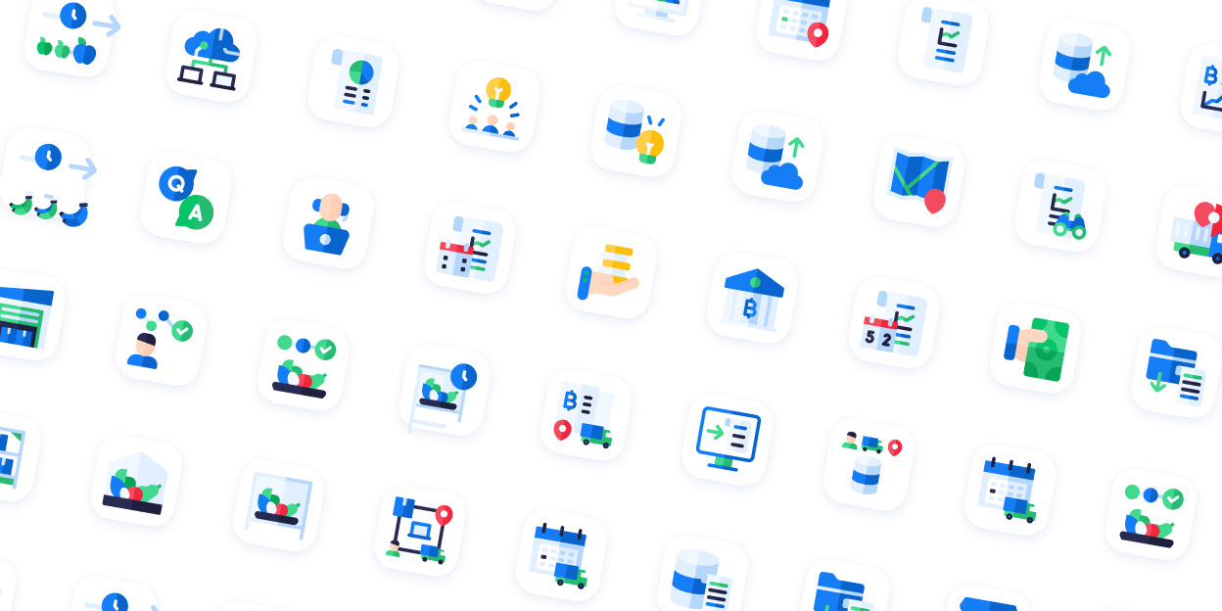

#### **Icon Style**

For beneficial reasons, designers should follow the Flat icon 2D style to apply in AXONS designs because

| **Clarity and Simplicity** | Flat icons are easy to understand and recognize due to their simplicity. They clearly represent objects, actions, and concepts without unnecessary details or distractions. |
| --- | --- |
| **Consistency** | Flat icons contribute to design consistency within a user interface. The uniform and 2D style can help create a cohesive and harmonious visual language across platforms. |
| **Readability** | Flat icons enhance readability and visibility by representing bold colors and straightforward shapes, even on small screens or in low-light conditions. |
| **Modern Aesthetic** | The flat design style is considered modern and aligns with contemporary design trends. It gives digital interfaces a fresh and up-to-date look. |
| **Universal Recognition** | Many flat icons have become universally recognized symbols for everyday actions or features. For example, a magnifying glass is widely understood to represent search functionality. |
| **User-Friendly** | Flat icons are user-friendly due to their simplicity and clarity. They help users navigate and interact with digital products more intuitively. |
| **Adaptability** | Flat icons can be customized and adapted to fit various design themes or branding guidelines while maintaining their fundamental 2D style. |
| **Accessibility** | Flat icons can be designed with accessibility principles in mind, such as using high-contrast colors and precise shapes, to ensure they are usable by a wide range of users, including those with disabilities. |

Overall, the flat icon 2D style balances aesthetics and functionality, making it a popular user interface and graphic design choice for its practical advantages.

#### **Icon Size**

The primary function of icon colors is to maintain consistent icon designs with uniform weight and details, streamline UI work, ensure a user-friendly experience, and simplify icon grid implementation, aiding inaccessible details and weight control.

| **48px** | **64px** | ***96px*** |
| --- | --- | --- |
|  |  |  |
| Pixel grid: 48x48px  Circle (Diameter): 40px  Square: 36x36px  Rectangle (Horizontal): 40x32px  Rectangle (Vertical): 32x40px | Pixel grid: 64x64px  Circle (Diameter): 56px  Square: 50x50px  Rectangle (Horizontal): 56x44px  Rectangle (Vertical): 44x56px | Pixel grid: 96x96px  Circle (Diameter): 80px  Square: 70x70px  Rectangle (Horizontal): 80x62px  Rectangle (Vertical): 62x80px |

#### **Icon Color**

"Colorful minimalism" means only using color in essential visual areas of an image. This helps users focus on the main point and understand the image's intended meaning more accurately.



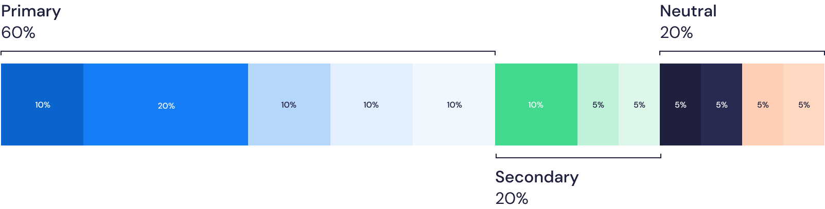

### **Illustration design**

Illustration design is the representative visual creation made using drawings, paintings, or digital art. It conveys messages and stories and enhances visual appeal in various applications, such as advertising, branding, and user interfaces.

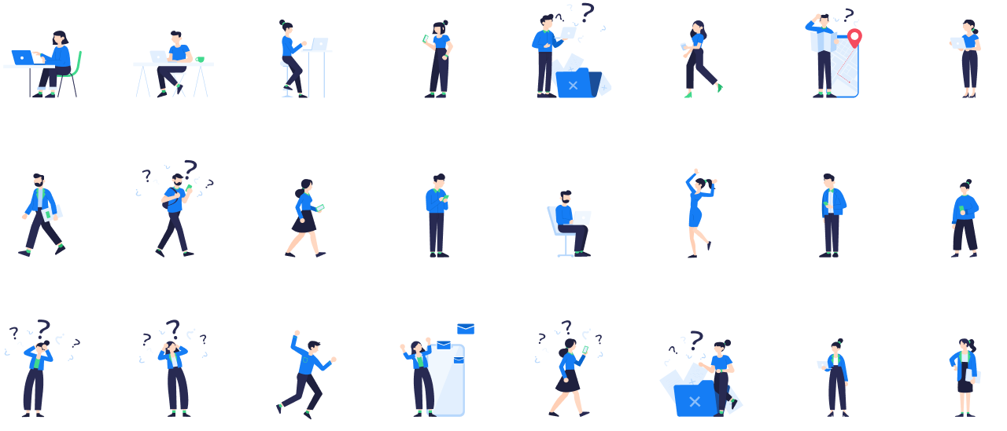

#### **Illustration Style**

Designers can apply flat icon 2D style to improve designs in various aspects, like

| **Clarity** | 2D illustrations are known for straightforwardness, which makes them easy to understand and reduces the risk of misinterpretations. |
| --- | --- |
| **Versatility** | Because of their adaptability, these illustrations can be used in a wide range of design contexts, from user interfaces to marketing materials. |
| **Simplicity** | 2D illustrations convey complex ideas with simplicity and clarity through visual,  making them suitable for a broad audience. |
| **Quick Recognition** | Users tend to quickly recognize and comprehend 2D illustrations, which aids in efficient communication. |
| **Universal Recognition** | Their straightforward nature makes 2D illustrations understandable across different cultures and languages, promoting inclusivity. |
| **Quick Production** | Creating and modifying 2D illustrations are typically faster than their 3D counterparts, which can expedite design projects. |
| **Accessibility** | Due to their simplicity, 2D illustrations are accessible to many users, including those with visual impairments. |
| **Adaptability** | 2D illustrations can be easily modified and customized to suit specific design requirements, offering flexibility in design projects. |

#### **Illustration Colors**

"Colorful minimalism" means only using color in essential visual areas of an image.

This helps users focus on the main point and understand the image's intended meaning more accurately.





## **Iconography**

It's crucial for simplifying complex concepts and improving user experiences in various designs and interfaces.

### **Principle**

In the AXIO design system, we predominantly employ **"Bold outline cons"** in the icon system. This stems from their seamless integration with UI elements, creating an aesthetically pleasing and well-organized appearance that keeps UI components straightforward. The simplicity of the design ensures that it can be adapted for various purposes and effectively communicates meaning to audiences.

System icons are crucial in indicating essential actions necessary for UI page operation and are used as status indicators. This approach enhances user comprehension and interaction with the UI, ultimately contributing to a positive user experience.

|  | **Icon Size & Layout**  ystem Icons follow Google Material Design guidelines, using a standard frame size of 24x24DP to maintain consistency and details across various UI elements.  *(DP refers to Density-Independent Pixels)* |
| --- | --- |
|  | **Live Area**  According to the icon grid of 24x24DP, we establish a "Live area" size of 20DP for designed icons and add a 2DP Padding  to create space separation between the icon and UI elements. This ensures icons are not too closely aligned.  If the icon's visual weight demands it, it can extend beyond the padding area, but it shouldn't surpass the red border (Trim area) to maintain consistency in size, proportion, and details. |
|  | **Geometric Shape**  The System Icons are founded on geometric shapes like circles, triangles, squares, and rectangles. This ensures our icons are consistently simple and aesthetically pleasing.  **Perfect Pixels**  We meticulously align icons with the pixels when exported to ensure they are distortion-free and not pixelated. This way, we adhere to the pixel-perfect principle and guarantee that the image is correctly displayed. |
|  | **Stroke & Corners**  The system icons typically have a stroke thickness of 1.5-2DP to ensure a consistent and stable appearance. The rounded corners have a radius of 1.5-2DP, aligning with the line thickness, and the inner shapes maintain angular edges for uniformity. |

### **Style**

To ensure icon consistency, designers should follow the design rules with proportional relationships between size, stroke thickness, color, and detail levels.

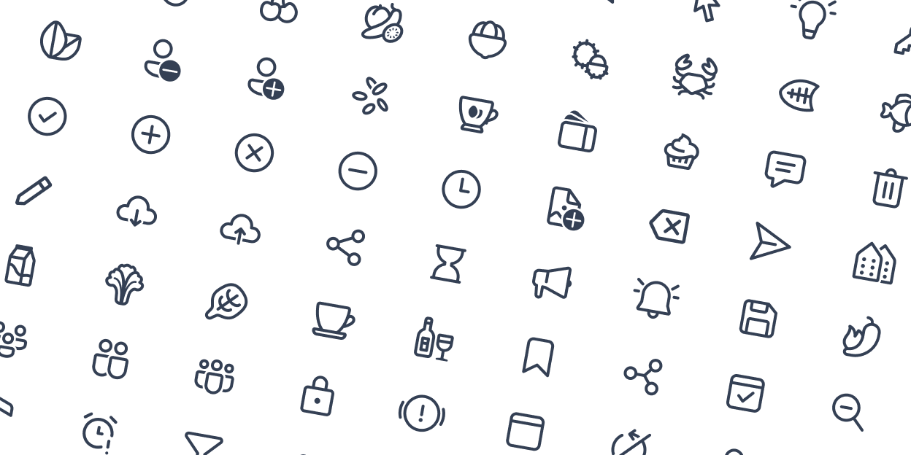

## **Imagery**

Imagery refers to the use of visual elements, such as pictures and graphics, to convey information or enhance communication in various media. It adds visual context and appeal to content, playing a crucial role in design, branding, and storytelling.

### **Principle**

Images should be **clear, visually pleasing, and comprehensive.** The photos used in experience designs shouldn't only be for aesthetics but also assist users in grasping the essence of the AXONS brand and products. Images should convey meaningful information and hold the viewer's interest, contributing to the product's overall appeal and making it visually appealing.



| **Informative**  The images should be easily understandable and aid in conveying and communicating the message to users more clearly. | **Delight**  Images should be impactful enough to enhance user satisfaction. | **International**  Images should effectively communicate their messages and be universally understandable. |
| --- | --- | --- |

Simple:



### **Usage**

#### **Framing**

Designers should use a 2x grid to arrange the image's composition when choosing images effectively.

This aids in positioning objects within the image, ensuring that key elements are centered or aligned to the left or right side. Also, the 2x grid applies to both vertical and horizontal photos.

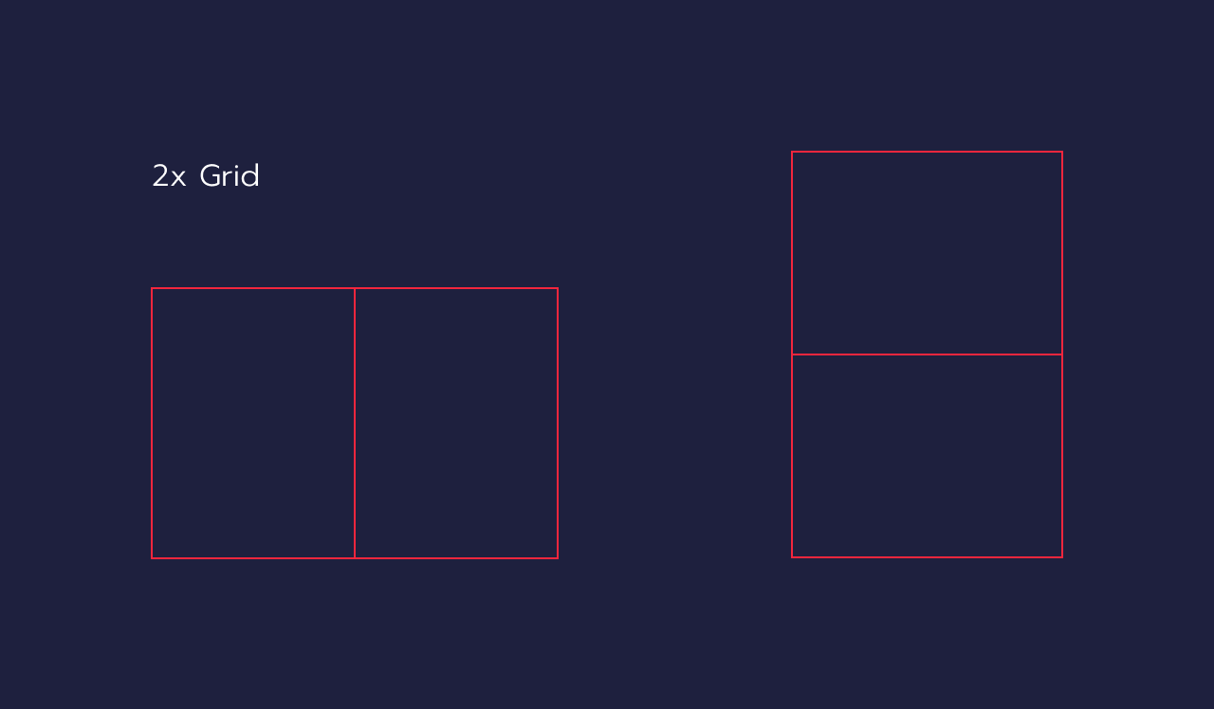

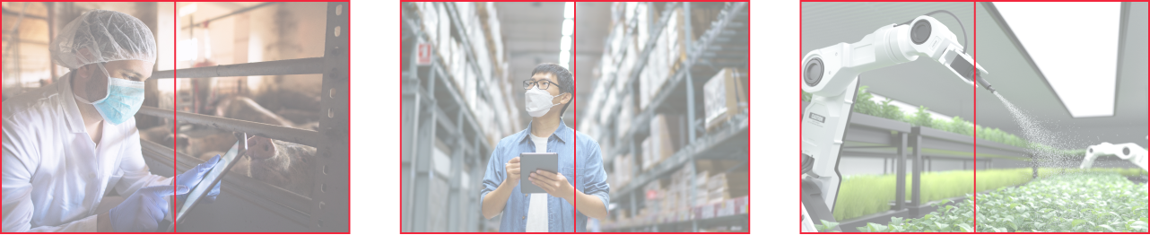

#### Focal Point

The focal point is the focus in images, where the viewer's attention is drawn to interpret the picture's meaning. In simpler terms, it attracts people's interests, with other elements around it contributing to the storytelling. Utilizing the 2x grid makes establishing a focal point in images easier.

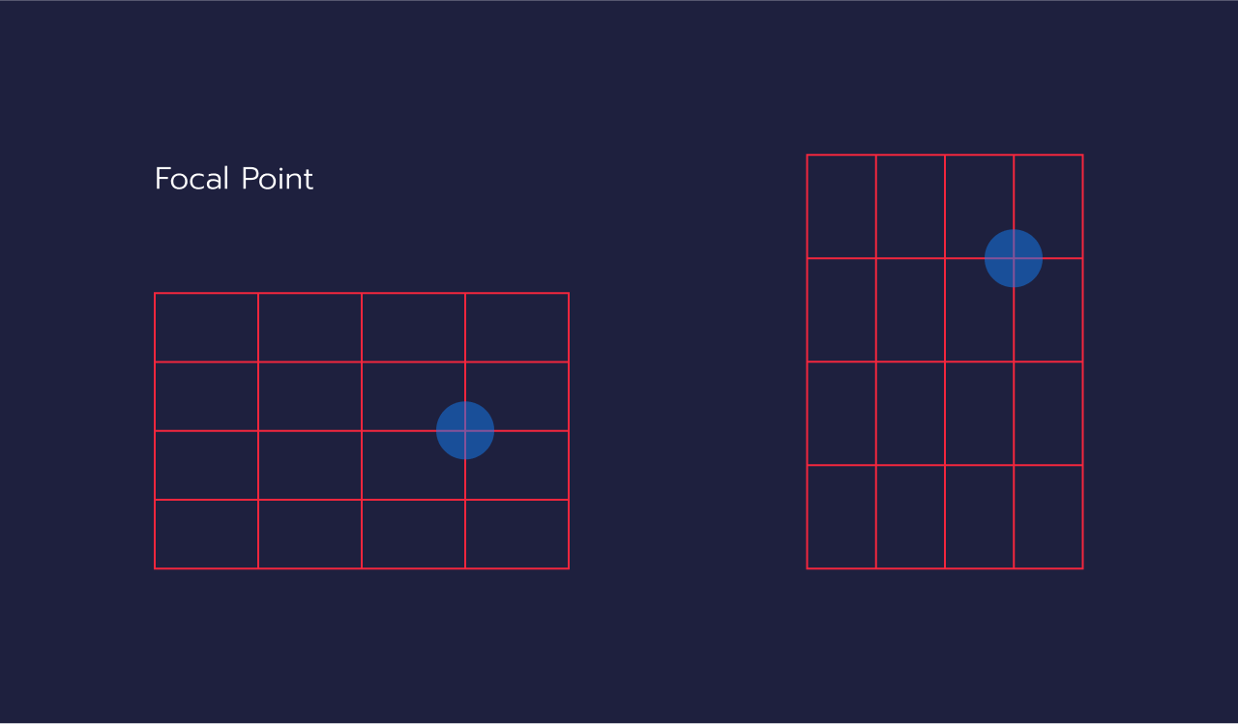

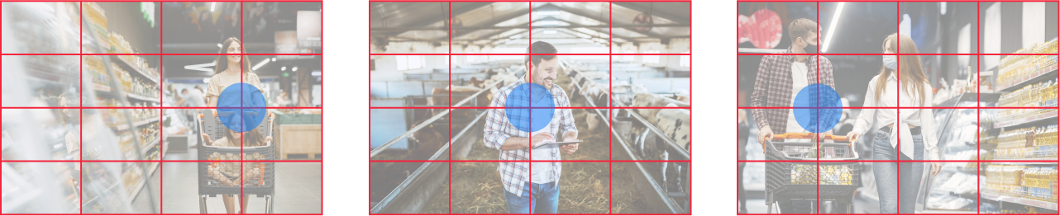

#### **Aspect Ratio**

Aspect ratio comprises two terms: "Aspect," denoting perspective, and "Ratio," referring to proportion, involving the width (horizontal) and height (vertical) of an image. A colon separates these two numbers (:).For example, 3:2 signifies the image has three parts width and two parts height, and so forth. Every ratio can be employed with the 2x grid, creating captivating and natural image compositions.

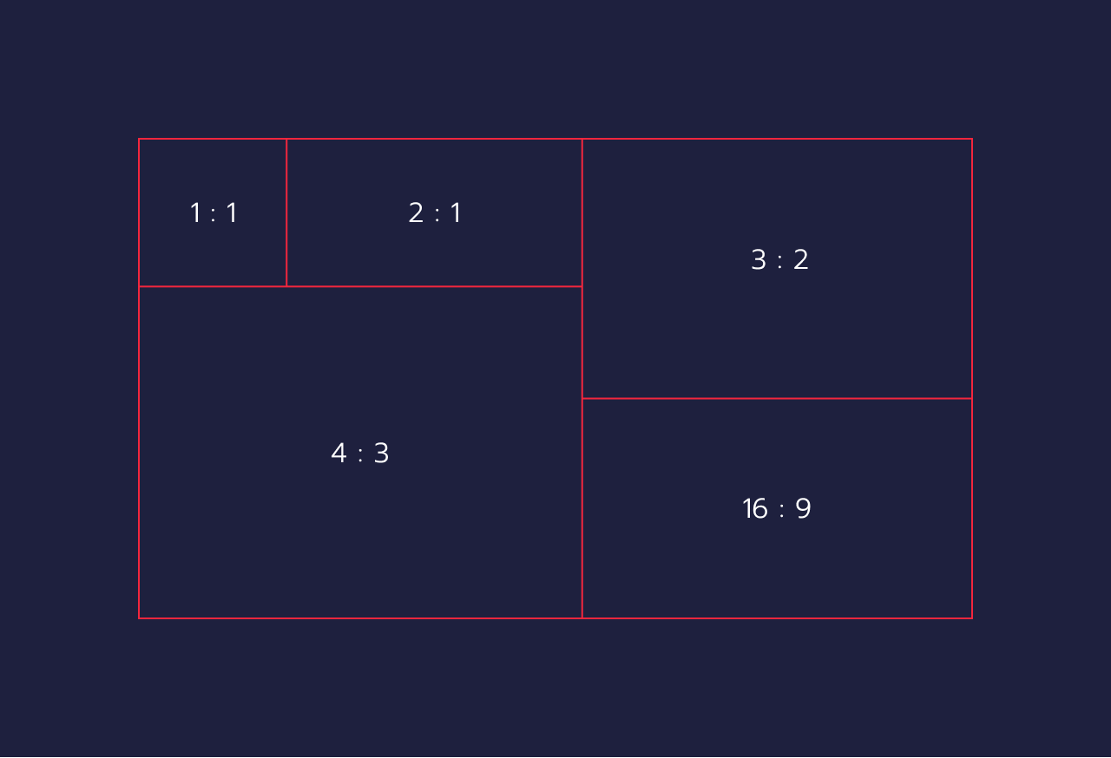

### **Style**

#### Lighting and Temperature

At first, people recognize that sunlight can promote happiness-inducing hormones, alleviate depression, and aid in preventing vision deterioration. Similarly, incorporating natural light into images can render them vibrant, balanced, and lifelike. This not only lends a natural appearance to pictures but also leaves viewers feeling refreshed and at ease.

Recommended image:



Not recommended image:



#### Resolution

It's crucial to consider image resolution to ensure versatility across various aspect ratios. Opting for high-resolution images lends a professional touch to our work and maintains the neatness of UI design. However, program loading must be taken into account; image sizes should strike a balance—large enough for clarity yet not so large as to hinder program performance and not too small to appear pixelated.

Recommended image:



Not recommended image:



#### Effect and Filter

For a natural and easily accessible appearance, images should avoid excessive effects or filters, as these can render them untrustworthy and unrealistic. Avoid artificial coloring or lighting that deviates significantly from reality unless it's necessary to incorporate text or various UI elements into the image.

Recommended image:



Not recommended image:

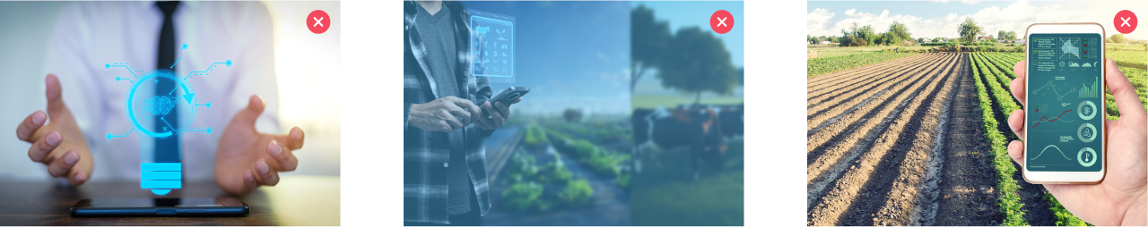

## **Elevation**

Elevation in design refers to the visual depth and element layers in a user interface, creating hierarchy and spatial relationships. It helps users understand the importance of elements and layouts through techniques like shadows and highlights, enhancing usability and visual appeal.



Elevation in UI components conveys hierarchy and depth within a user interface. It's a visual technique that helps users understand the relative importance and arrangement of different elements on the screen.

|  |  |
| --- | --- |
| **Card Shadow** | **Bar Shadow** |

The important thing is that shadows shouldn't signal clickability or scroll ability; designers should consider and ensure that the shadow indicating a component is dragged or moved from its original position.

### **Shadow Style**

#### **Card Shadow**

| **For Gray Background**  fill: rgba(255, 255, 255, 1.0)  shadow: 0.0px 0.0px 15.0px 0px rgba(59, 89, 152, 0.1) | **For White Background**  fill: rgba(255, 255, 255, 1.0)  shadow: 0.0px 3.0px 10.0px 0px rgba(132, 147, 198, 0.12), 0.0px 1.0px 6.0px 0px rgba(181, 201, 235, 0.15) |
| --- | --- |

#### **Bar Shadow -** Use for Sidebar and Navigation bar components

| **For All Background**  fill: rgba(255, 255, 255, 1.0)  shadow: 0.0px 3.0px 5.0px 0px rgba(132, 147, 198, 0.12),0.0px 1.0px 18.0px 0px rgba(181, 201, 235, 0.21) |
| --- |

## **Corner Radius**

The corner radius is considered one of the most important UI elements; it's the roundness of a UI component's corners. It helps designers measure pixels (px) in images. Also, the corner radius impacts the component's appearance and style, making it more dimensional.



### **Radius Value**

Radius values are component measurements that help determine the corners' smoothness and sharpness.

These values are crucial for maintaining a consistent and visually appealing design in user interfaces.

| **Corner radius value** | **Used for** |
| --- | --- |
| 16px | Large container components |
| 12px | Medium components like popup dialogs and cards |
| 8px (Default) | Medium or small components that often live inside others |
| 4px | Small components |

### **Usage**

#### 16px

|  |
| --- |

Significant container components have rounded corners, often used in visuals like sections or cards. This can create a soft mood and present an inviting look to users.

#### 12px

|  |
| --- |

These are the medium-sized components found in the visual, like panels or blocks. The overall visual appearance will be more modernized when designers apply the corner radius, which features a balanced pixel shape of 12 pixels.

#### 8px

|  |
| --- |

Formally, the default pixel shape of an 8-pixel radius is suitable for medium and small components like cards, buttons, and banners, offering a versatile and clean design. Designers should consider applying this radius type by placing it inside larger ones, such as card buttons.

#### 4px

|  |
| --- |

The pixel shape of 4 pixels in radius is often used in small components, like small card buttons. Designers should apply it to enhance attraction and create an impactful look for users.

# **DESIGN PHILOSOPHY**

## Layout Grids

A grid layout in a design system is a fundamental framework that helps designers and developers create a consistent, structured, and visually appealing interface across various devices and screen sizes.

### Overview

#### Grid System

A grid is a series of intersecting horizontal and vertical lines used to structure content. These grids provide a flexible template for arranging graphical elements (like text, images, buttons, and other components) harmoniously and organized.

| 1 Col | 1 Col | 1 Col | 1 Col | 1 Col | 1 Col | 1 Col | 1 Col | 1 Col | 1 Col | 1 Col | 1 Col |
| --- | --- | --- | --- | --- | --- | --- | --- | --- | --- | --- | --- |
| 4 Column | | | | 4 Column | | | | 4 Column | | | |
| 4 Column | | | | 8 Column | | | | | | | |
| 6 Column | | | | | | 6 Column | | | | | |
| 12 Column | | | | | | | | | | | |

In Axontech's responsive design approach, utilizing a flexbox-based grid layout ensures adaptability to various screen sizes. Bootstrap's GrGrid, for instance, allows up to 12 columns per page, offering extensive flexibility in layout design. You're not obligated to use all 12 columns; multiple columns can be merged to form wider ones, accommodating content of varying sizes.

This feature enables designers to place content in selected grid boxes without filling every single one, much like merging cells in an Excel spreadsheet. It's essential to plan these layouts carefully: regardless of how columns are combined or expanded (ranging from 1 to 12 grid columns), the total should always sum up to 12 in each row. This systematic approach ensures a balanced, harmonious layout consistent with Axontech's commitment to creating intuitive, user-friendly designs.

#### Components of a Grid Layout

| **Columns** | Vertical blocks that content is aligned to. The number of columns can vary depending on the design's complexity and the device's screen size. |
| --- | --- |
| **Gutters** | The spaces between columns help maintain whitespace, ensuring the content doesn't feel cramped. |
| **Margins** | The space around the outer edge of the grGridseparating the content from the edge of the screen or page boundary. |
| **Rows and Baselines** | Horizontal spacing can align elements vertically and help maintain vertical rhythm in text content. |

|  |
| --- |

#### Types of Grids

|  |  |
| --- | --- |
| **Fixed Grids**  They have fixed-width columns and are typically used for desktop designs. | **Fluid Grids**  These adapt to the screen width, with column widths defined as a percentage of the screen size, making them ideal for responsive design. |

### 

### Usage

The grid layout is inherently responsive, which dynamically adjusts to the screen's resolution at any moment. This adaptability ensures that the column arrangement is automatically reconfigured to suit the changing dimensions of the screen, providing an optimal viewing experience across different devices. During the mockup design phase, it's essential to consider the number of columns appropriate for each device screen. Employing this grid layout streamlines the design process and significantly accelerates system development, providing developers with a clear, consistent framework for implementing the design.

#### How to use Layout Grids

| 1.Select Artboard | 2.Select Grid Styles | 3.Used the Grid Style |
| --- | --- | --- |

#### Grid Brackpoint

| **Desktop** | |
| --- | --- |
| For desktop displays, the grid layout in the AXONS' design system is optimized for screen sizes ranging from 1024px to 1440px and above. This ensures the design maintains clarity and usability on larger screens suitable for a desktop environment. | |
| **More than 1440px** | The grid is capped at 12 columns, with a consistent 16px spacing between them. For screens over 1440px, columns are ideally 84px wide.  Using **1440px for desktop mockups is recommended**, aligning with modern device-friendly standards. |

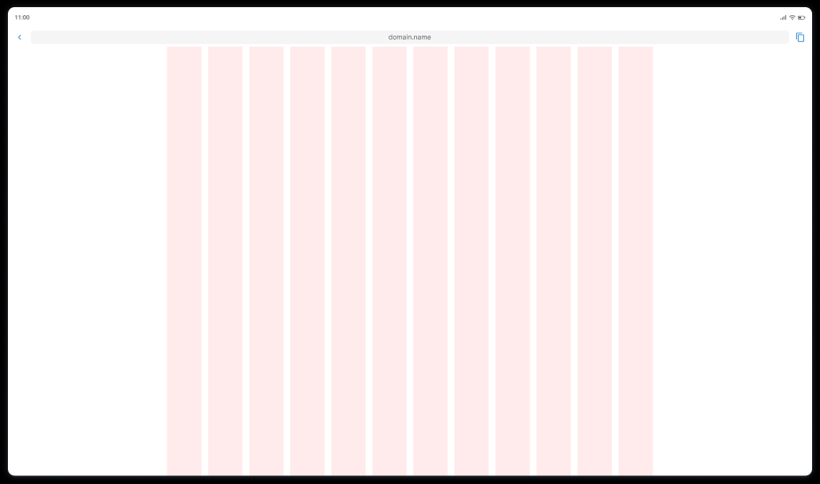

Example desktop screen size: 1920px

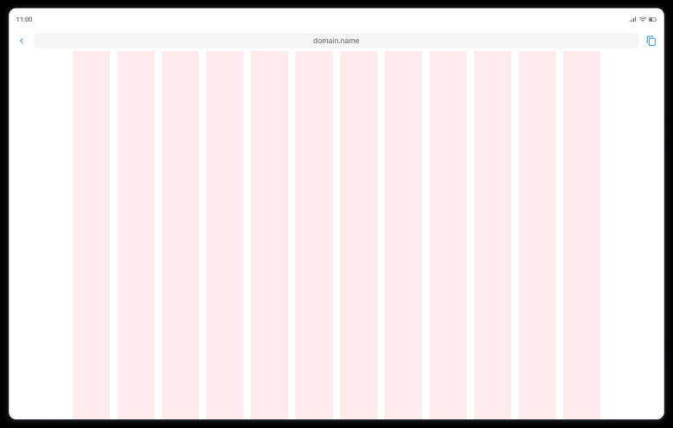

Example desktop screen size: 1440px

| **Less than 1440px** | The grid setup consists of 12 columns, mirroring the standard desktop configuration. Each column is separated by a 16px spacing, ensuring a harmonious layout. The width of these columns is dynamically adjusted to stretch across the entire screen, providing a balanced and comprehensive view.  Additionally, a 32px margin is maintained on both the left and right sides of the screen, creating an aesthetically pleasing and well-organized space for content. |
| --- | --- |

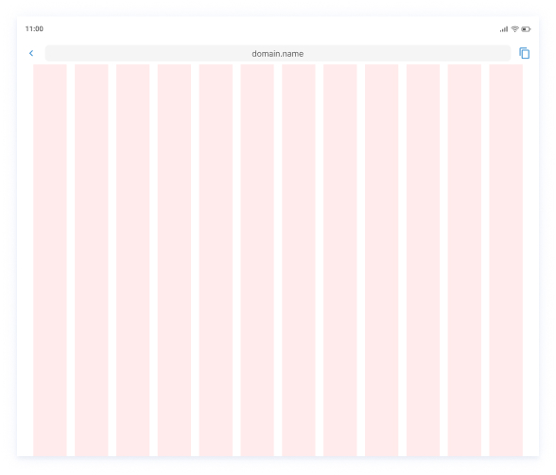

Example desktop screen size: 1024px

| **Tablet** | |
| --- | --- |
| For desktop displays, the grid layout in the Axontech design system is optimized for screen sizes **ranging from 1024px to 1440px and above**. This ensures the design maintains clarity and usability on larger screens suitable for a desktop environment. | |

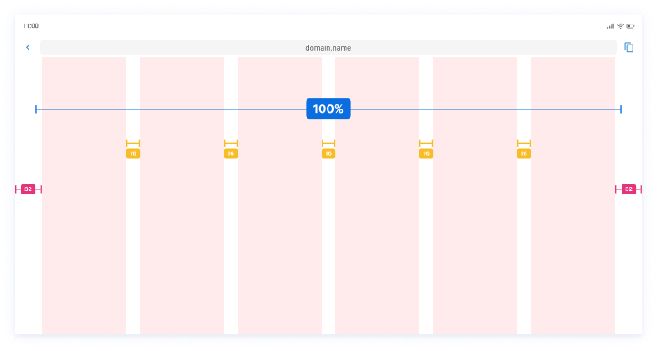

Example desktop screen size: 744-768px

| **Mobile** | |
| --- | --- |
| The grid is meticulously designed for **screens that are not more significant than 420px for mobile devices.** This approach caters to mobile devices' compact form factor, ensuring an optimal user experience that is both fluid and user-friendly. | |

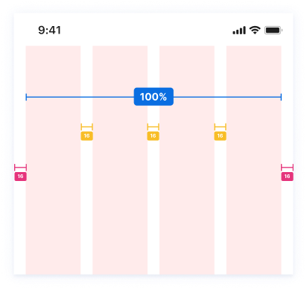

Example desktop screen size: 320-428px

## Dimensions

the breadth and depth of content covered in the documentation that supports a design system. It's not just about physical measurements, but rather the scope and detail provided

### **Principles**

| **Unified Sizing System** | Our design framework is built on a base unit of 2 or 4, facilitating consistent sizing across various elements. This uniform approach aids in creating designs where components align perfectly, enhancing overall visual cohesion. |
| --- | --- |
| **Structural Harmony** | The spacing and sizing in our system are derived from a modular scale with a significant second ratio **(1.25 and base 2 number)**. This scale is pivotal in achieving a pixel-perfect fit and a visually pleasing arrangement. |

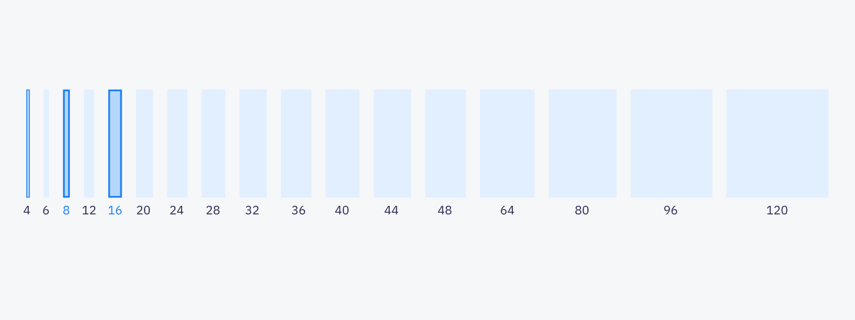

### **Key Design Elements**

| **Spacing Guidelines** | The incremental spacing scale, rooted in our base unit of 2 or 4, is crucial for defining the space between objects within our product designs. This systematic spacing helps maintain balance and proportion throughout our layouts. |
| --- | --- |
| **Preferred Size Options** | Although the full range of increments of 2 or 4 is available, our designers primarily utilize five primary size archetypes. These sizes have been selected for their versatility, effectively covering the majority of layout requirements. |

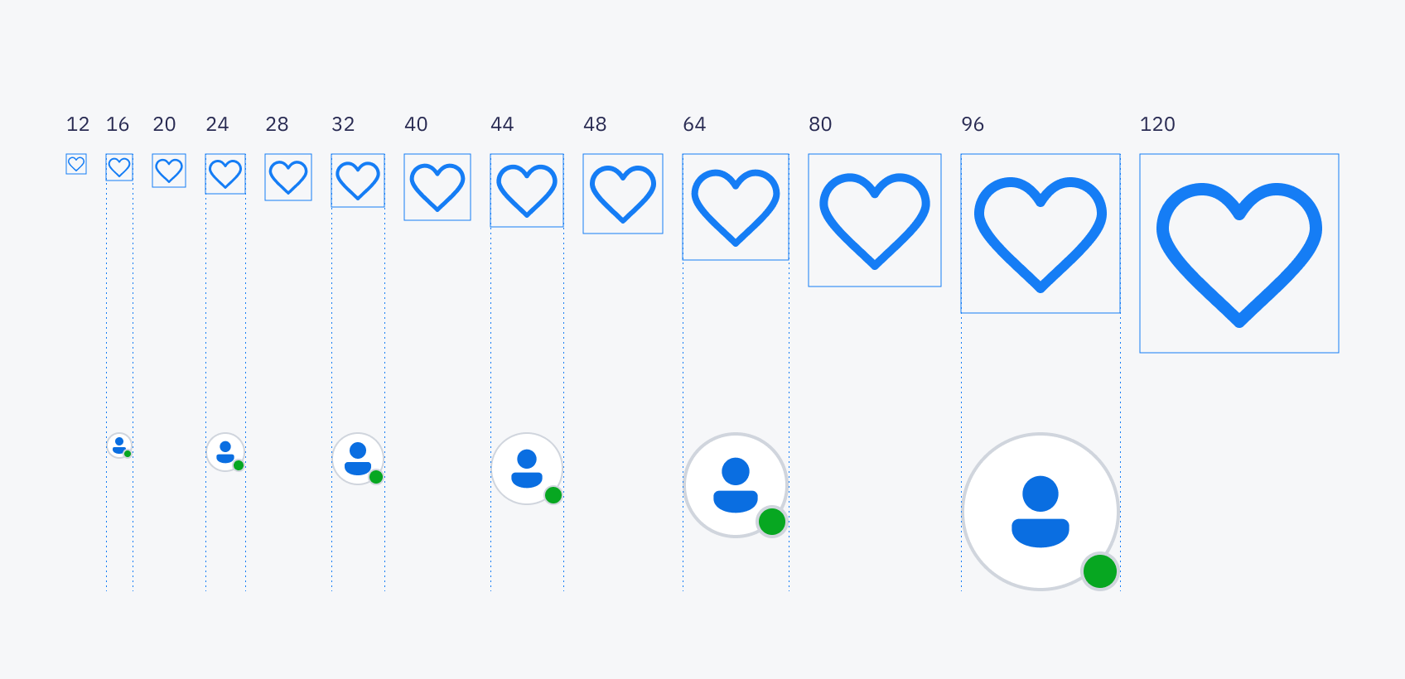

### **Additional Considerations**

| **Flexibility and Adaptability** | While we emphasize these core sizes, our design system is also for flexibility. Designers can adapt and modify these standards when unique design challenges or innovative layout concepts arise. |
| --- | --- |
| **Consistency Across Platforms** | This dimensional approach is not just limited to one design aspect; it extends to grid structures, typography, and component design, ensuring a harmonious and consistent experience across all user interfaces. |

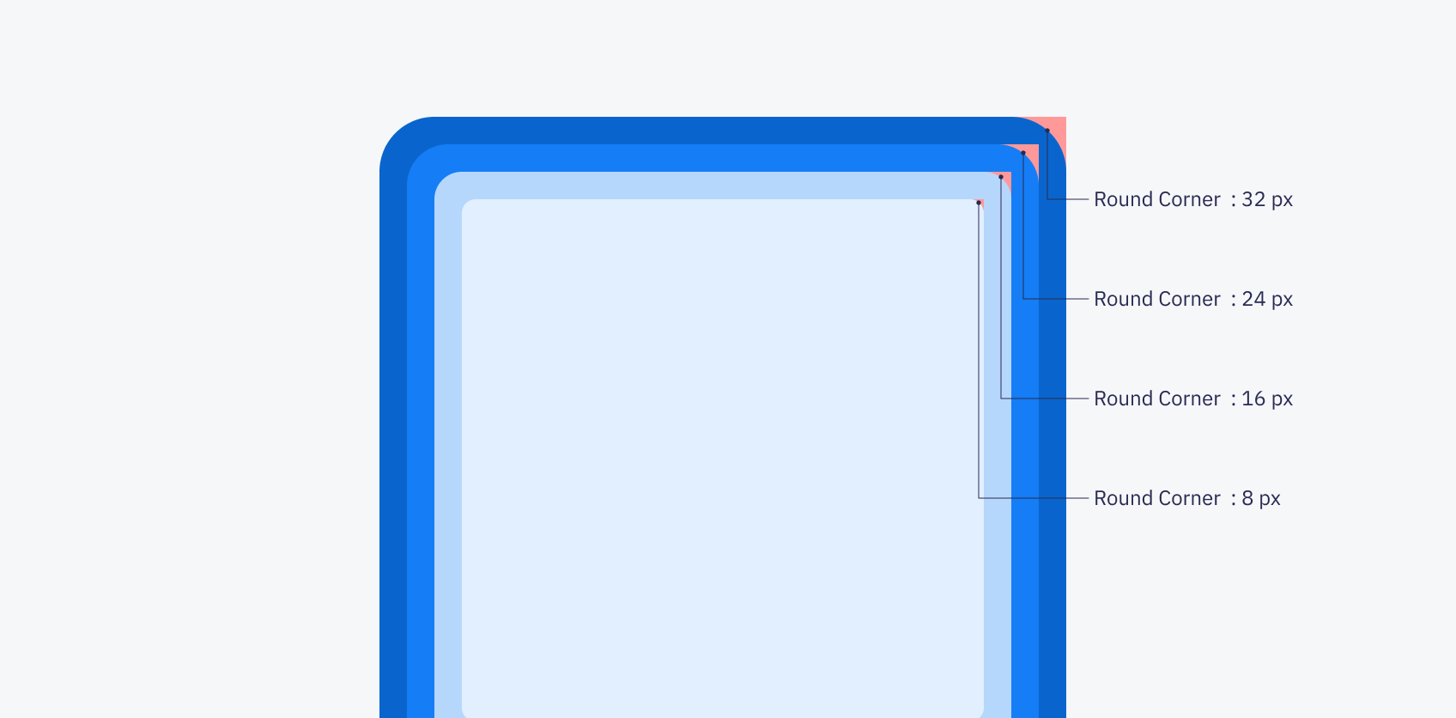

### Typography

Typography relates to the design of alphabet forms for communication and is one of the fundamentals of typefaces and font design to fit in spaces and other visual elements.

#### Overview

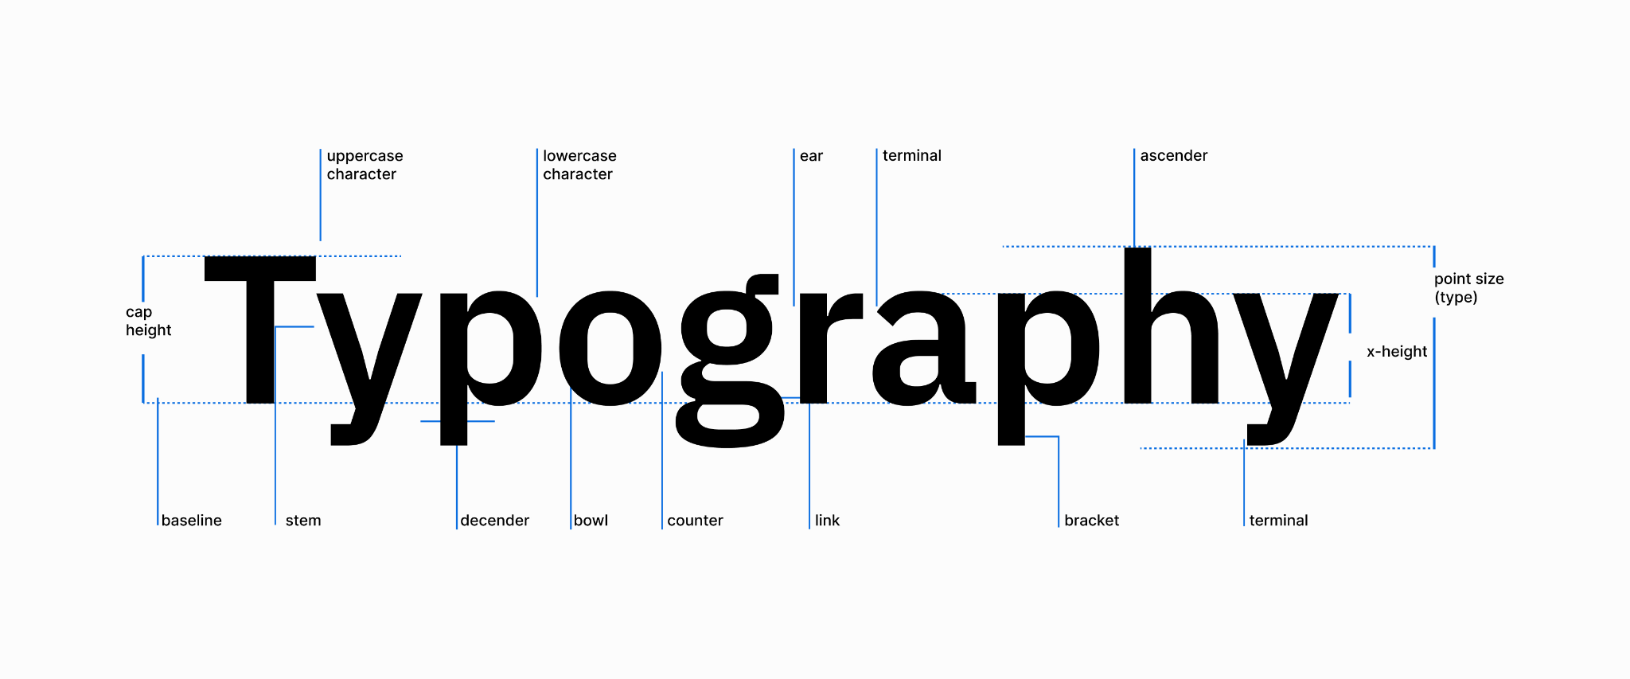

##### Introduction

Typography is a fundamental aspect of our design language at AXONS. It not only carries the voice of our brand but also ensures that our digital experiences are accessible and transparent. IBM Plex Sans Thai has been chosen as our primary typeface because of its excellent readability and contemporary feel, which aligns with the brand's global and inclusive identity.

##### Typeface

**IBM Plex Sans Thai** is the cornerstone of our typographic strategy. It's designed to work seamlessly across all digital platforms and supports Thai and Latin scripts. This typeface combines aesthetic quality with practical functionality, making it suitable for a wide range of applications, from user interfaces to long-form text.

**License Information:** IBM Plex Sans Thai is an open-source typeface that is free for commercial use. You can download it directly from [Google Fonts](https://fonts.google.com/specimen/IBM+Plex+Sans+Thai) or [GitHub](https://github.com/IBM/plex).

##### Usage Guideline

In AXONS, designers will mainly use the font family property of IBM Plex Sans Thai as an element in all product development projects. Also, typography is divided into three types based on devices: web responsive, mobile application, and kiosk.

To design a better experience for our users, designers should consider personas when designing typography. The critical reason why the structure of typography contains three types of usage in all devices is based on different personas: high-tech and low-tech.

* **Consistency:** Maintain consistent use of specified text styles and scales across all platforms.
* **Avoidance of Over-styling:** Limit multiple font weights on a single page to avoid visual clutter and confusion.

| **Usage patterns for each type of font** | |
| --- | --- |
| **Display** | Used for text or sentences that want to stand out especially, such as on banners, on advertising images, etc. |
| **Header** | Used for text or sentences that displays the main topic or menu at the top of a web page, document, or application. |
| **Title** | Used for text or sentences that represent the title of the content, which is often used to tell users what the content is about. |
| **Body** | Used to define the main content of a web page or document. |
| **Text Link** | Used for text that has embedded links (Hyperlinks) that, when clicked, will take the user to other related pages or content. |
| **Paragraph** | Used for paragraphs that divide content into categories, which contain a large amount of information, such as terms and conditions of service, legal requirements, etc. |

##### Web Responsive Usage

**High-tech**

*The base font is 16 px in design* ***(1 rem = 16 px) for DEV.***

| **Display** | | | |
| --- | --- | --- | --- |
| **Style name** | **Font Weight** | **Font Size** | **Line Height** |
| D3 Semi-Bold | Semi-Blod (600) | 40 | 52 |
| D4 Semi-Bold | Semi-Blod (600) | 32 | 40 |
| D5 Semi-Bold | Semi-Blod (600) | 24 | 32 |
| D6 Semi-Bold | Semi-Blod (600) | 18 | 26 |
| D7 Regular | Regular (400) | 14 | 20 |
| D7 Semi-Bold | Semi-Bold (600) | 14 | 20 |
| **Header** | | | |
| **Style name** | **Font Weight** | **Font Size** | **Line Height** |
| H2 Bold | Bold (700) | 32 | 48 |
| H4 Bold | Bold (700) | 24 | 36 |
| H6 Semi-Bold | Semi-Bold (600) | 18 | 26 |
| **Title** | | | |
| **Style name** | **Font Weight** | **Font Size** | **Line Height** |
| T2 Semi-Bold | Semi-Bold (600) | 22 | 32 |
| T3 Semi-Bold | Semi-Bold (600) | 20 | 30 |
| T4 Semi-Bold | Semi-Bold (600) | 18 | 28 |
| T5 Semi-Bold | Semi-Bold (600) | 16 | 24 |
| **Body** | | | |
| **Style name** | **Font Weight** | **Font Size** | **Line Height** |
| B3 Regular | Regular (400) | 18 | 28 |
| BH3 Semi-Bold | Semi-Bold (600) | 18 | 28 |
| B4 Regular | Regular (400) | 16 | 24 |
| BH4 Semi-Bold | Semi-Bold (600) | 16 | 24 |
| B5 Regular | Regular (400) | 14 | 22 |
| BH5 Semi-Bold | Semi-Bold (600) | 14 | 22 |
| B6 Regular | Regular (400) | 12 | 18 |
| BH6 Semi-Bold | Semi-Bold (600) | 12 | 18 |
| **Text Link** | | | |
| **Style name** | **Font Weight** | **Font Size** | **Line Height** |
| LU3 Regular (Underline) | Regular (400) | 18 | 28 |
| L3 Regular | Regular (400) | 18 | 28 |
| LU4 Regular (Underline) | Regular (400) | 16 | 24 |
| L4 Regular | Regular (400) | 16 | 24 |
| LU5 Regular (Underline) | Regular (400) | 14 | 22 |
| L5 Regular | Regular (400) | 14 | 22 |
| **Paragraph - change the font-family to “IBM Plex Sans Thai Looped”** | | | |
| **Style name** | **Font Weight** | **Font Size** | **Line Height** |
| P3 Regular | Regular (400) | 18 | 32 |
| PH3 Semi-Bold | Semi-Bold (600) | 18 | 32 |
| P4 Regular | Regular (400) | 16 | 28 |
| PH4 Semi-Bold | Semi-Bold (600) | 16 | 28 |
| P5 Regular | Regular (400) | 14 | 26 |
| PH5 Regular | Semi-Bold (600) | 14 | 26 |

##### Mobile or Tablet Application Usage

**High-tech**

*The base font is 16 px in design* ***(1 rem = 16 px) for DEV.***

| **Display** | | | |
| --- | --- | --- | --- |
| **Style name** | **Font Weight** | **Font Size** | **Line Height** |
| D3 Semi-Bold | Semi-Blod (600) | 40 | 48 |
| D4 Semi-Bold | Semi-Blod (600) | 32 | 40 |
| D5 Semi-Bold | Semi-Blod (600) | 24 | 32 |
| D6 Semi-Bold | Semi-Blod (600) | 18 | 26 |
| D6 Regular | Regular (400) | 18 | 26 |
| D7 Semi-Bold | Semi-Bold (600) | 16 | 22 |
| D7 Regular | Regular (400) | 16 | 22 |
| D8 Semi-Bold | Semi-Bold (600) | 14 | 18 |
| D8 Regular | Regular (400) | 14 | 18 |
| **Header** | | | |
| **Style name** | **Font Weight** | **Font Size** | **Line Height** |
| H2 Bold | Bold (700) | 32 | 40 |
| H4 Bold | Bold (700) | 26 | 32 |
| H5 Bold | Bold (700) | 22 | 30 |
| H6 Bold | Bold (700) | 18 | 26 |
| **Title** | | | |
| **Style name** | **Font Weight** | **Font Size** | **Line Height** |
| T2 Semi-Bold | Semi-Bold (600) | 22 | 32 |
| T3 Semi-Bold | Semi-Bold (600) | 20 | 28 |
| T4 Semi-Bold | Semi-Bold (600) | 18 | 24 |
| T5 Semi-Bold | Semi-Bold (600) | 16 | 22 |
| T6 Semi-Bold | Semi-Bold (600) | 14 | 20 |
| **Body** | | | |
| **Style name** | **Font Weight** | **Font Size** | **Line Height** |
| B3 Regular | Regular (400) | 18 | 26 |
| BH3 Semi-Bold | Semi-Bold (600) | 18 | 26 |
| B4 Regular | Regular (400) | 16 | 24 |
| BH4 Semi-Bold | Semi-Bold (600) | 16 | 24 |
| B5 Regular | Regular (400) | 14 | 22 |
| BH5 Semi-Bold | Semi-Bold (600) | 14 | 22 |
| B6 Regular | Regular (400) | 12 | 18 |
| BH6 Semi-Bold | Semi-Bold (600) | 12 | 18 |
| **Text Link** | | | |
| **Style name** | **Font Weight** | **Font Size** | **Line Height** |
| LU3 Regular (Underline) | Regular (400) | 18 | 26 |
| L3 Regular | Regular (400) | 18 | 26 |
| LU4 Regular (Underline) | Regular (400) | 16 | 24 |
| L4 Regular | Regular (400) | 16 | 24 |
| LU5 Regular (Underline) | Regular (400) | 14 | 22 |
| L5 Regular | Regular (400) | 14 | 22 |
| **Paragraph - change the font-family to “IBM Plex Sans Thai Looped”** | | | |
| **Style name** | **Font Weight** | **Font Size** | **Line Height** |
| P4 Regular | Regular (400) | 16 | 24 |
| PH4 Semi-Bold | Semi-Bold (600) | 16 | 24 |
| P5 Regular | Regular (400) | 14 | 22 |
| PH5 Regular | Semi-Bold (600) | 14 | 22 |